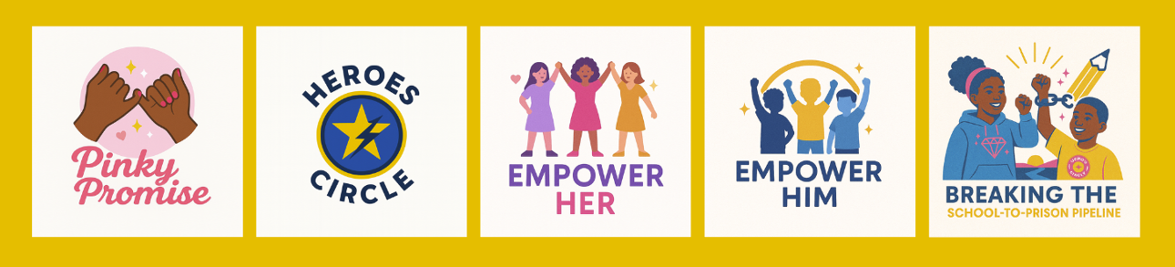
💎 Shine Bright Like A Diamond Youth Organization

Partnership Overview —
Who We Are
Shine Bright Like A Diamond Youth Organization empowers youth and families to break barriers, build confidence, and thrive. Through mentorship, leadership development, family support, and community programming, we equip young people with the skills and support needed to succeed academically, emotionally, and socially.
Our Mission
To uplift youth and families by providing mentorship, life skills, and leadership development that supports academic success, emotional wellness, and purpose-driven living.
Our Vision
A world where every young person has the opportunity to grow, lead, and shine bright.

Our Core Task Forces (Programs)
🌸 Pinky Promise (Girls Empowerment)
Builds confidence, self-worth, sisterhood, and creativity through affirmation circles, mentorship, and the annual Daddy & Daughter Dance.
⭐ Heroes Circle (Boys Leadership)
Develops integrity, teamwork, resilience, and character through mentorship circles, leadership workshops, and acts of service.
💎 Empower Her
Prepares high-school and young adult women for college, careers, and leadership through coaching, confidence-building, and professional development.
🖤 Empower Him
Supports young men with workforce readiness, emotional wellness, leadership development, and life-skills training.
🔗 Breaking the School-to-Prison Pipeline
Provides advocacy, parent workshops, system navigation, restorative support, and educational equity resources for families facing discipline challenges.

Why Partner With Us
Partnerships allow us to expand programming, strengthen family support, and increase our impact across schools, churches, and community centers. Your collaboration helps provide:
- Community mentorship programs
- Leadership workshops and youth circles
- Family engagement and advocacy services
- School-based interventions
- Empowerment events that build connection and confidence

Together, we create safer, stronger, and brighter futures for youth.

Partnership Opportunities
- Program Sponsor (support one Task Force)
- School or Church Partner (host programs onsite)
- Event Sponsor (Daddy & Daughter Dance, youth summits, workshops)
- Community Collaborator (nonprofits, government, or civic groups)
- In-Kind Supporter (supplies, venues, volunteers, professional expertise)

What Partners Receive
- Recognition on website, publications, and social media
- Logo placement on flyers & event materials
- Access to collaboration opportunities with our youth task forces
- Invitations to special events & community showcases
- Annual impact summary for your records and reporting

Contact Us
Shine Bright Like A Diamond Youth Organization
📧 info@shinebrightlikeadiamond.org
📍 St. Louis, Missouri
🌐 Website: www.shinebrightlikeadiamond.org

